Wetherby School  Little Wetherby and Reception  19 Pembridge Villas  London  W11 3EP | Wetherby School  Years 1, 2 and 3  11 Pembridge Square  London  W2 4ED

E-Safety Policy

Policy reviewed by: Mark Snell and Helen Milnes

Review date: May 2016

Submission: May 2016

Policy actioned from: September 2016 – August 2017

Next review date: May 2017
Reviewer’s Signature:
Head Teacher’s Signature:

Circulation: This policy is addressed to all members of staff and volunteers, is available to parents on request. It applies wherever staff or volunteers are working with pupils.

Please note: ‘School’ refers to Wetherby School; ‘parents’ refers to parents, guardians and carers.

E-safety Policy

Contents

- Scope and definition
- Responsibilities
- Training & CPD
- Understanding the types of E-safety risk
- Key principles and controls
- Technological controls
- Parental responsibilities and off-site E-safety
- Reporting of E-safety incidents

Appendices

- 1 - E-Safety Incident Log form
- 2 - E-Safety Incident Flowchart

Scope and definition

This policy is part of our strategy for safeguarding children within our care. It complies with Keeping Children Safe in Education (KCSIE) September 2016.

E-safety is a broad term which we use to refer to the safeguarding of children in relation to the risks arising from ever-evolving new media and technologies such as: the internet, mobile phones, tablets, computers, gaming devices, instant messaging, social media, collaboration tools, personal publishing, and ‘apps’ in general.

The responsible use of technology is a multi-dimensional, social and behavioural issue. Although the generic term ‘E-safety’ implies a response to some specific risks (as described below), we do not regard it as a stand-alone topic. It is embedded within our educational processes and consequently we take a holistic approach to keeping children safe. This policy should therefore be read in conjunction with our other policies, notably:

- Safeguarding
- Anti-Bullying
- Learning for Life (PSHEE)
- Use of Mobile Phones and other Electronic Devices
- Images
- ICT Usage
- Social Media

Responsibilities

The Headmaster, Deputy Head (Pastoral) and the Designated Safeguarding Leads have primary responsibility for the implementation and maintenance of this policy. Taking into account the multi-dimensional aspects of E-safety, it is essential that specific responsibilities are also clearly assigned to specific individuals based on their skills and experience.

Aspect of E-safety | Designated person
ICT Leader | Vanda Varga
On-site Engineer | Jagdave Sangha
Curriculum - ICT | Vanda Varga
Curriculum - PSHEE | Helen Milnes and Jason Smith
Staff Training & CPD | Mark Snell and SMT
Development of Parental Awareness | Helen Milnes

Clarification of the relationship between the ICT Leader and the On-Site Engineer

Although the maintenance of technological controls (see section below) such as internet filtering, and data and network security are the responsibility of the Alpha Plus Group Director of ICT and administered by the On-Site Engineer, it is essential that a member of school staff is nominated as ICT Leader and is assigned responsibility for monitoring the effective delivery of these services on behalf of all school users, and for reporting problems where necessary. The ICT Leader may well be also responsible for the ICT curriculum, but it is important that these two responsibilities are clearly understood as separate functions.

Training and CPD

Those responsible for E-safety will keep up to date on current E-safety issues and guidance issued by the Government and by organisations such as their Local Authority, CEOP (Child Exploitation and Online Protection), and Childnet International.

Consistent with our Safeguarding policy, all staff:

- receive information and training on E-safety, both at induction, and at regular intervals thereafter (minimum annually),

- have a duty to be alert to E-safety, and to share any concerns with the DSL (and others as appropriate in the context).

Understanding the types of E-safety risk

Risks commonly associated with new media and technology are broad. In most cases the risks are not intrinsically caused by technology, but technology may increase the ease and likelihood of occurrence, and increase the scope of potential harm. Risks include:

- Predatory behaviours such as grooming, abuse or radicalization,
- The corruption of young minds through the normalization of disrespectful, or anti-social language and behaviour through exposure to age-inappropriate content, especially: violence, pornography, racism, sexism, gambling, advertising, etc.
- Extensions of ‘off-line’ peer-behavioural risks, e.g. cyber-bullying, ‘trolling’,
- The misplaced perception that aggressive, offensive and inconsiderate on-line language or behaviour is somehow less damaging and more acceptable than their equivalents off-line or face to face.
- The degradation of educational and maturing processes arising from a child’s misplaced judgement of the accuracy, reliability or contextual propriety of online content,
- Breaking laws, e.g. sexting, copyright infringement, data protection/privacy breaches,
- The lasting damage to self-esteem and to reputation which children may incur (to themselves or to others, thoughtlessly or maliciously) by distributing or publishing confidential, insensitive, offensive or otherwise inappropriate content,
- Exposure to fraud, hacking or identity-theft through insufficient security of passwords and personal details,
- The use of new media and technology in distracting or addictive ways.

In order to develop age-appropriate responses to this wide range of risks, we categorise them, along with related learning objectives, as follows (adapted from Tanya Byron’s ‘3 C’s of E-safety’):
Risk category | Commercial | Aggressive | Sexual | Values
Content  Child is observer/consumer | Understand and develop resilience to advertising, spam, sponsorships and demands for personal information | Develop resilience to violent/hateful content and know how to cope and to deal with it | Avoid/develop resilience to pornographic or unwelcome sexual content | Develop critical evaluation skills to Identify bias, prejudice, misleading and manipulative information and advice
Contact  Child is participant | Awareness of tracking, harvesting and the protection of personal information | Develop resilience to being bullied or harassed, and know what actions to take | Understand the implications of interacting with strangers and being groomed | Develop resilience to the risk of compulsive/addictive online behaviour, and to unwelcome persuasions
Conduct  Child is instigator/perpetrator | Clear guidance on illegal downloading, copying, plagiarising, hacking, gambling, fraud, identity theft and the consequences | Clear guidance on bullying, harassment or ‘trolling’ of others and understand the consequences | Clear guidance on creating and uploading inappropriate material and understand the consequences | Clear guidance on the value of personal integrity, respect, data security, confidentiality, and the consequences of publishing inappropriate, false or misleading information or advice

Key principles and controls

We take E-safety very seriously. In addition to all the general safeguarding principles and controls included within our Safeguarding policy, the over-arching principle with E-safety is the need to educate children about the risks and benefits of using new media and technology, and to help them to operate safely, legally, productively, thoughtfully and considerately in the digital world. This includes the development of independent thinking and critical evaluation skills to help determine the reliability, accuracy and integrity of on-line content.

E-safety is incorporated into the curriculum, not only within ICT and Learning for Life (PSHEE) lessons, but wherever and whenever it makes sense to reinforce concepts at an age-appropriate level. This includes assemblies, guest speakers, and parent information events. We believe that the internet and the constantly evolving technologies and devices to which children have access can be tools that enrich their lives. We therefore teach them to view technology and new media positively whilst simultaneously protecting themselves.

Technological controls

In addition to the educational measures to promote E-safety within the curriculum, we maintain specific controls which enable us to establish a secure data and communications environment and to monitor children’s digital activity within the boundaries of the school. Foremost amongst these are:

- Children to whom we provide bespoke access to ICT resources are asked to agree in writing to a set of rules for the acceptable use of such resources (see ICT Usage policy).

- Our password-controlled network maintains individual security, confidentiality and accountability for activity on the network.

- We use well-established and frequently updated filtering software to prevent access to content deemed to be potentially harmful, and which records attempts to access such potentially harmful content. If staff or children discover unsuitable sites, the URL (web address) must be reported to the ICT Leader. Any member of the school community should report a website which causes them concern to the ICT Leader who will immediately refer this to the on-site engineer who will arrange for that site to be blocked.

The scope of the technological controls mentioned above extends across all our network of computers and internet-enabled devices, and across any Wi-Fi access which the school operates.

Whilst these filtering controls can similarly apply to mobile phones which use the school Wi-Fi, we cannot (legally or technically) monitor private phone activity, e.g. texting, or applications or internet content which are accessed via 3G and 4G signals. For this reason we operate a strict policy on the use of mobile phones (see separate policy document).

Our staff are authorised to search for and to confiscate any device, and to search the device and (if appropriate) delete content, if they consider that it is being used in an inappropriate way. Inappropriate usage will be dealt with consistent with our policies on discipline, behaviour, sanctions and exclusions.

The school ICT Leader has specific responsibility for monitoring the effectiveness of the technological controls section of this policy, under the direction of the Alpha Plus Group Director of ICT.

Parental responsibilities and off-site E-safety

Given that children’s engagement with the digital world extends well beyond the school premises, we expect parents to remain alert to their children’s activities and behaviour. We recognise that this is a broad and open-ended task which many parents find challenging. We therefore direct parents towards on-line resources which can help parents to take preventative action which will promote E-safety, and help them to identify risk-indicators of potentially problematic behaviour. We host workshops for parents to support strategies for staying safe online and we expect parents to attend at least one of these annually.

Regarding the responsibility of schools/colleges to deal with E-safety incidents which occur ‘off-site’, the Education and Inspections Act 2006 and the Education Act 2011 empower the school/college, to such extent as is reasonable, to:
- regulate the behaviour of children when they are off the school site where an E-safety incident is linked to the school/college

- impose disciplinary penalties for inappropriate behaviour

- search for and confiscate electronic devices, and search their contents, and where appropriate delete content

Reporting of E-safety incidents

An E-safety incident, which includes the discovery of a specific or heightened risk, must be reported as soon as possible. If it in any way touches on child safeguarding issues, then it must be reported immediately to the DSL, consistent with the Safeguarding policy. Similarly, if it involves cyber-bullying, then the Anti-bullying policy must be followed.

If it relates to technological controls (as described above), or to a breach of the ICT Usage policy, then it must be reported to the ICT Leader.

Other members of staff and management should be informed as appropriate in the circumstances.

A log of E-safety incidents should be maintained. The reporting of E-safety Incidents should include the following data:

- Name of person reporting the incident
- Date and time of incident
- Date reported
- Names of people involved
- Location and device details
- Details of incident, including evidence where possible
- Clarification of the risk or breach – e.g. does it relate to safeguarding, bullying, inappropriate content, sexting, data protection, copyright infringement…etc.? Use the 3 C’s categorisation as described earlier in this policy.
- Initial action taken and current status

Once investigated, a record of the resolution of the incident, and actions taken as a result, must be maintained. Such records should be readily available for inspection during governance visits.

Appendix 1

E-Safety Incident Log Form

Name of person reporting incident:
Date and time of incident:

Date incident reported:

Names of people involved:

Location and device details:

Details of incident, including evidence:

Clarification of the risk or breach e.g. does it relate to safeguarding, bullying, inappropriate content, data protection, copyright, infringement, sexting, etc? (Use 3Cs categorisation):

Initial action taken and current status:

Resolution of incident:

Appendix 2

E-Safety Incident Flowchart
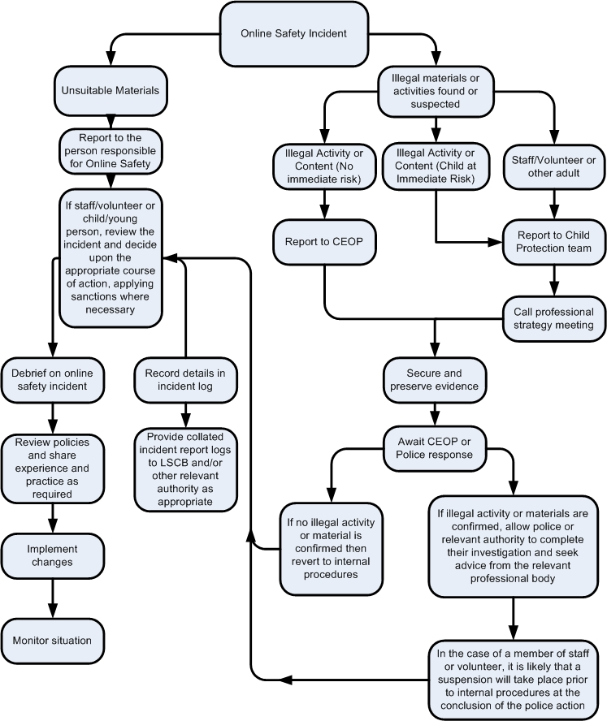

Please report any e-safety issues to either the Headmaster, Deputy Head (Pastoral) or the Designated Safeguarding Leads.

A person may cover more than one aspect if they have the appropriate experience and skills-set.
Even if not directly employed by Alpha Plus, the on-site engineer must sign the annual affirmation statement as required by the Code of Ethical & Professional Conduct (available on the Portal).
Online games designed for adults are often cited as one of the principle causes of concern for several of these risks. This may be as much from the highly aggressive and verbally abusive behaviours they elicit as from the be-friending of pseudonymous strangers or from exposure to violent and sexual content. Extensive exposure to such games may be considered evidence of child neglect, which may, in certain circumstances, lead schools/colleges to consider reporting parents to social services.
E.g. email accounts; network ID’s and accounts; unsupervised browsing
If in doubt, staff should consult their Head/Principal and the Department for Education guidance: Searching, screening and confiscation (February 2014).
Harmful content may be deleted, unless it is deemed necessary to pass it onto the police.
This may be understood as something of a serious nature which requires disclosure and remedial action.

